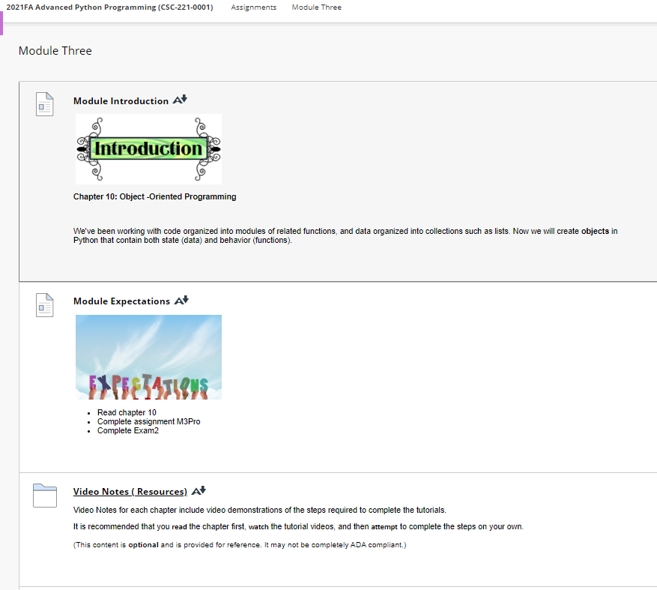

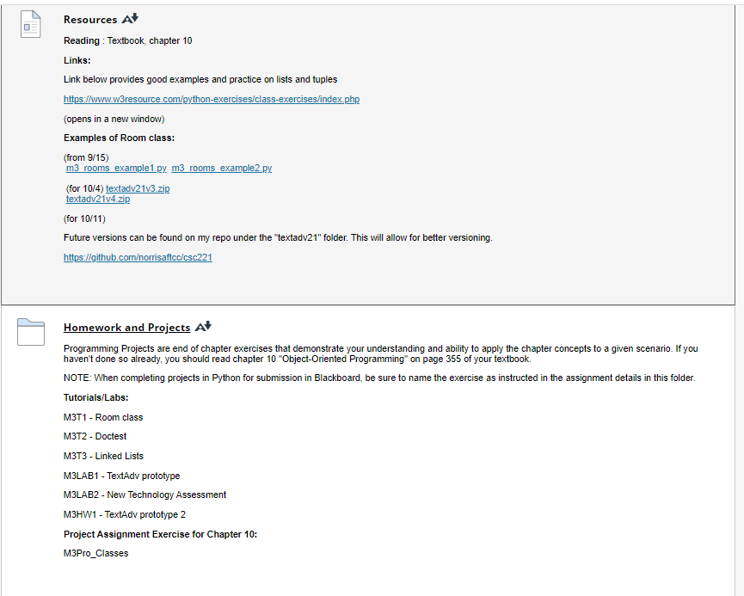

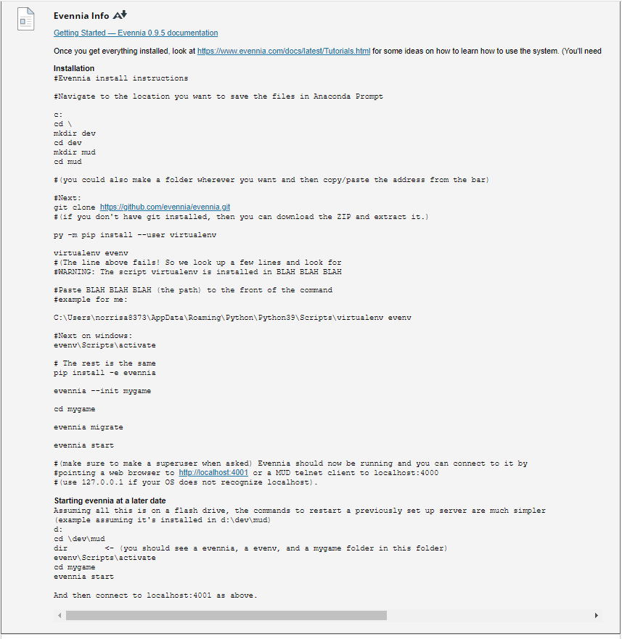

**Video Note : Class Definitions**

<https://mediaplayer.pearsoncmg.com/assets/afrrJiT9rjJFR00aHl9wJxIsorW43GvT>

A video tutorial on  **Class Definitions** from *Deitel & Deitel , Intro to Python*.

(This video is **optional** and is provided for reference. It may not be completely ADA compliant.)

**Video Note : Subclasses (Inheritance)**

<https://mediaplayer.pearsoncmg.com/assets/P6zkjoK0lJ7PbhTnKkbz7jox7xNLArPH>

A video tutorial on **Subclasses (Inheritance)** of *Deitel & Deitel , Intro to Python* explains how to import modules, use functions and preview list of functions in a module.

(This video is **optional** and is provided for reference. It may not be completely ADA compliant.)

### Resources

[Resources](https://faytechcc.blackboard.com/webapps/blackboard/content/listContent.jsp?course_id=_35059_1&content_id=_5950106_1)

**Reading** : Textbook, chapter 10

**Links:**

Link below provides good examples and practice on lists and tuples

<https://www.w3resource.com/python-exercises/class-exercises/index.php>

(opens in a new window)

**Examples of Room class:**

(from 9/15)  
 [m3_rooms_example1.py](https://faytechcc.blackboard.com/bbcswebdav/pid-5950110-dt-content-rid-55011542_1/xid-55011542_1)  [m3_rooms_example2.py](https://faytechcc.blackboard.com/bbcswebdav/pid-5950110-dt-content-rid-55012436_1/xid-55012436_1)  
   
 (for 10/4) [textadv21v3.zip](https://faytechcc.blackboard.com/bbcswebdav/pid-5950110-dt-content-rid-55374656_1/xid-55374656_1)  
 [textadv21v4.zip](https://faytechcc.blackboard.com/bbcswebdav/pid-5950110-dt-content-rid-55374657_1/xid-55374657_1)

(for 10/11)

Future versions can be found on my repo under the "textadv21" folder. This will allow for better versioning.

<https://github.com/norrisaftcc/csc221>